**GRADEBOOK**

As discussed earlier, the eAiiSH permits setting up of activities such as assignments, quizzes, discussions forums, chats etc.Upon successful completion of an activity, the student performance can be assessed and recorded in **Gradebook.** The Gradebook can be set up for each course**.** In the Gradebook,the teacher can registerthe assessment of the activities carried out on the **eAiiSH** platform and offline activities like written tests.

Before setting up the Gradebook, we have to determine the broad categories for assessment with the percentage of marks for each category. E.g.,Assignments, Presentations and Tests can be the three broad categories. Let’s give 30% each for assignments and presentations and 40% for tests. It is always better to plan the specific activities under each category, along with the number of instances and the specific marks/grade for each instance.

An example of the Categories and Items along with Percentage and Marks are given in table below.

|  |  |  |  |
| --- | --- | --- | --- |
| **Category** | **Weightage in Percentage** | **Items under the Category** | **Marks for each item** |
| Assignments | 20 | Assignment-C1 | 5 |
| Assignment-C2 | 5 |
| Presentations | 40 | Presentation-C1 | 10 |
| Presentation-C2 | 10 |
| Tests | 40 | Test-C1 | 10 |
| Test-C2 | 10 |
| **Total** | **100** |  | **50** |

After deciding the categories and items under each category along with the weightage and marks, login to the course home page.

1. Click the **Grades** link from the left Navigating Drawer, which will take you to the **Grader Report**. By default, it will display the ‘**view’** option of the ‘Grader Report’ listing the participants of the course (Figure….).

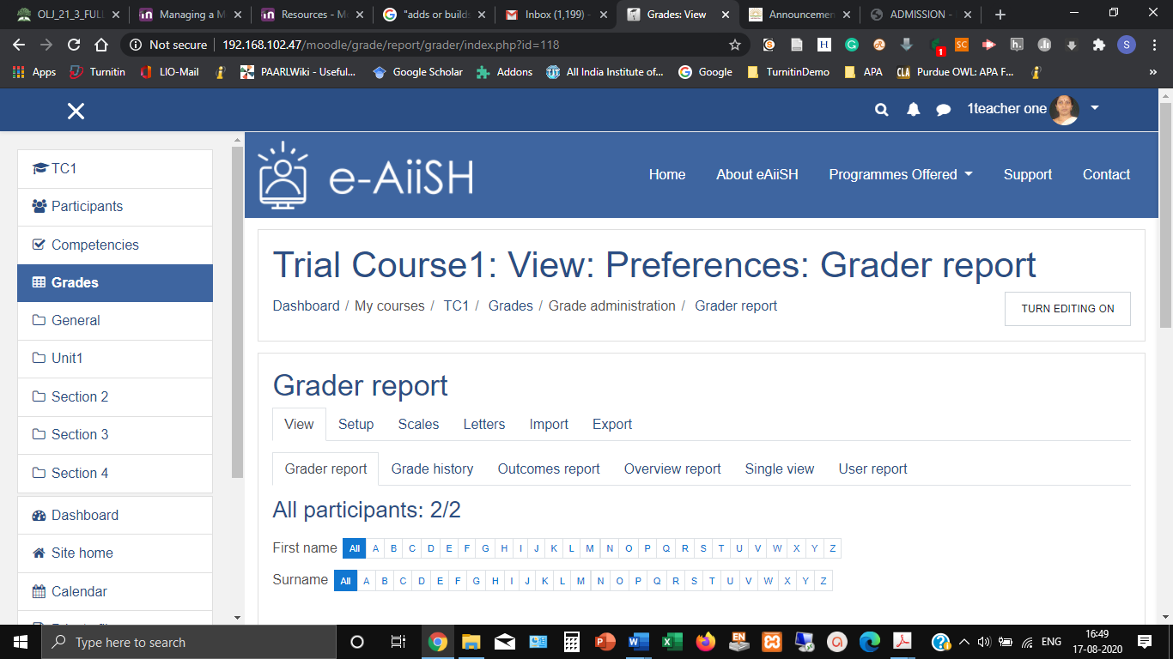

1. Click the **Setup** button**.** Now it is blankwith a folder icon carrying the name of the course (Figure ) and ‘ **Add Grade Item**’ and ‘ **Add Category**’ buttons at the bottom.

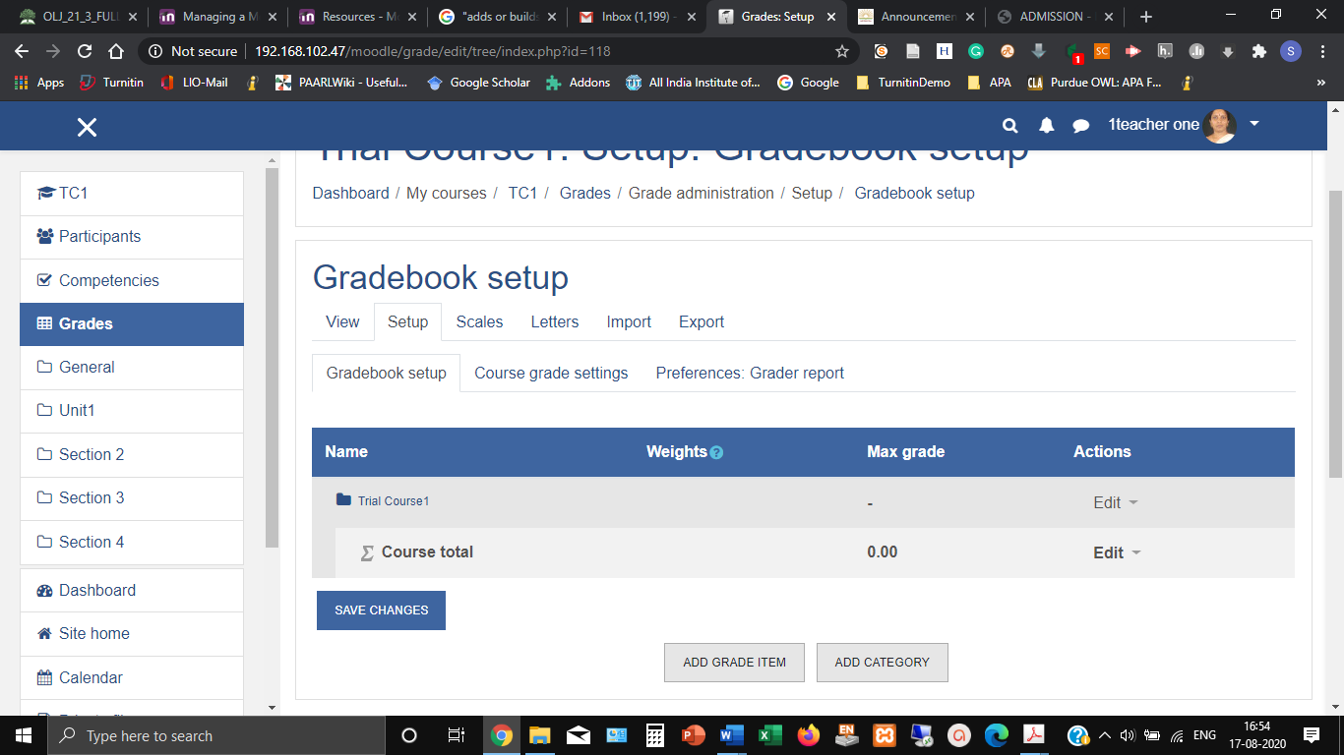

1. Now, click the **Add Category** button. Give a name for the category as decided earlier. Eg. ‘Assignments’. Below there is a button by the name **Aggregation,**which is nothing but the method of calculation of marks/ grade.The question mark against the aggregation lists the types of calculations and the default type is **Natural**.*i.e. sum of all grade values scaled by weight.*
2. Click the **Show more** link and tick the **exclude empty grade** option which will exclude a missing entry from grade calculation.
3. Click **‘Category Total’.**  Against **Maximum grade** enter the total number of marks allotted across C1 and C2 components. The grade display type is **Default (Real)**. At the bottom, tick the Weight adjusted box and enter the percentage of weight decided for the category. (*In our case for Assignments it is 20*). Do not add the percentage symbol. Just the digits 20.
4. Save changes
5. Now it will display the ‘weight’ against ‘Assignment’ as 20.
6. Add the next category i.e. ‘Tests’ and repeat the procedure. Remember to add Category weight as 40.
7. Similarly category of ‘Presentation’ has also been added with weightage of 40.
8. **Drop the lowest** option will permit a teacher to exclude the lower marks that a student score from aggregation.
9. **Keep the highest** option will give the same effect as the **Drop the lowest.** We can have either one of them.
10. The **‘Items’** have to be added while setting up the activity. They could be the number of instances of tests, or the different types of assignements and presentations.
11. In the example provided, each of these categories further have two sub-items under them one each for C1 and C2 components. The marks have been divided evenly between them, that is 20 + 20 for test and presentation and 10 + 10 for assignment. But the internal distribution of weightage will be 50(%) within each category category.

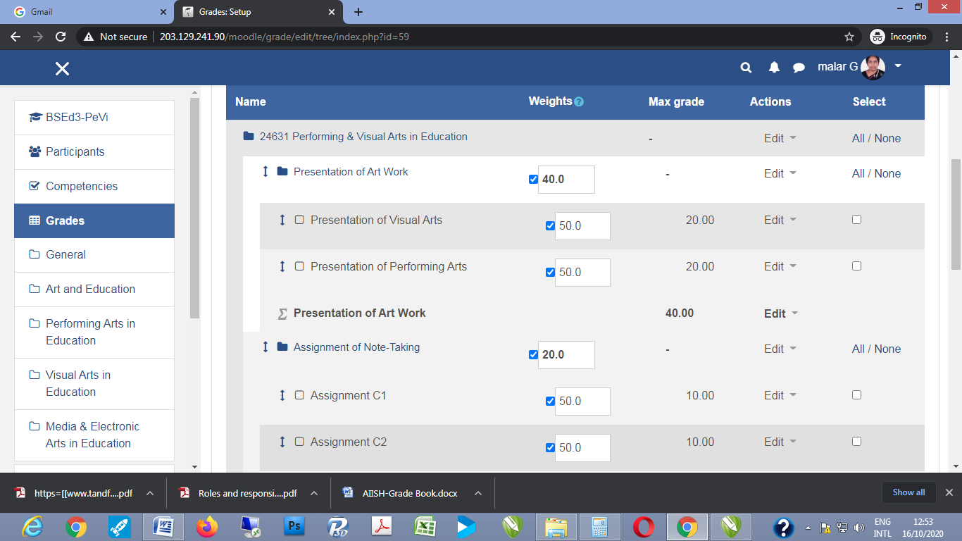

1. For offline assessment activities the marks could be entered manually. For this open **view** option of grader report. List of students with bare coloumns for marks will open up. Click into the **edit** icon, enter the marks into the editable column that opens and **save** the changes.
2. For bulk entries of marks, data if available in the form of comma separated excel (.csv) files, they could be uploaded directly by dragging and dropping the files into the allotted fields.
3. Some times teachers may carry out instances of assessment for varied scores among and within categories across the semester. Like for example, the first unit test may be for 20 marks, while the next test may be for 25 marks. One practical demonstration may be for 10 marks, wile the next may be for 15 marks. Such variations may be necessary according to the chaing depth of the subject matter, and increasing proficiency of the skill involved. In such instances, instead of selecting the **Natural Aggregation** mentioned under Sl. No. 3, it is better to go for **Weighted Means** as the mode for computing the course total.
4. In here, the overall weightage of each category and the internal weightage of the sub-items will have to be specified.